Notice
Online Draw of Lots for Admission to Bal Vatika 3 will take place in the Vidyalaya on 20th July 2023 at 9:30 am.
The Schedule is given below:
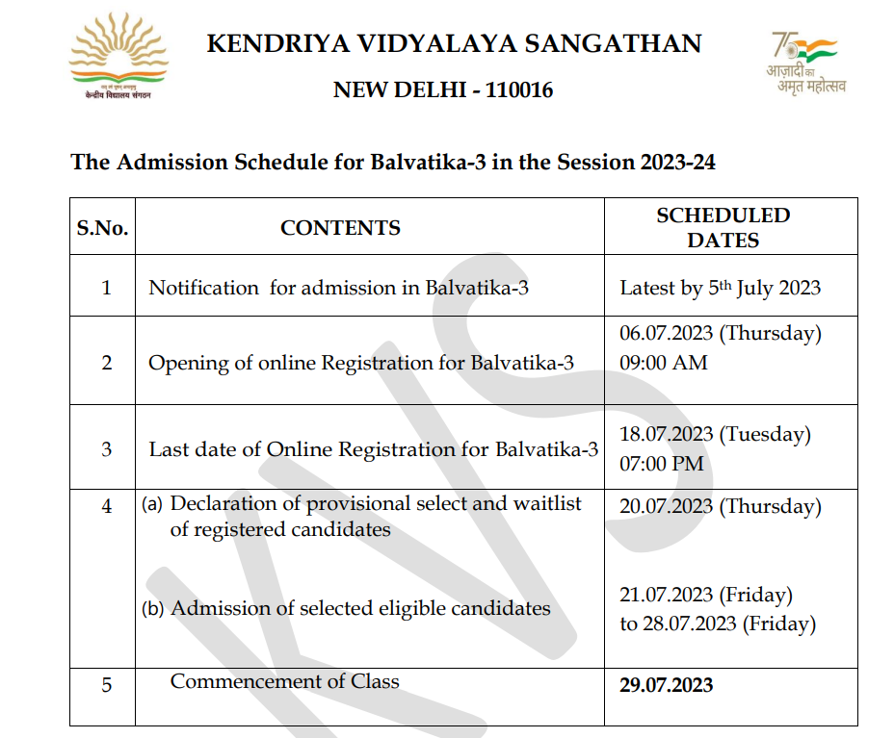

Principal

